**Git commands: -**

git init :

To initialize an existing directory as a Git repository



Git remote:

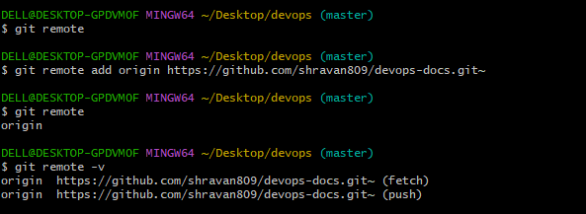

Git status:

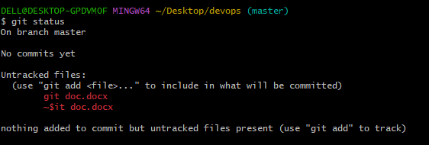

**Git add and git commit:**

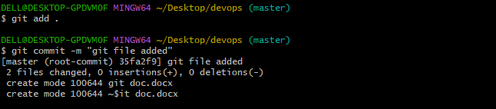

**Git checkout:**

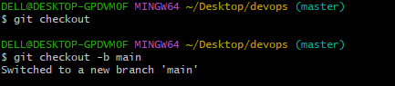

**Git branch:**